# Use Case 2 – Build a Supply Chain Disruption Response App using Fabric Databases

The objective of this hands-on lab is to build a Supply Chain Disruption Response App using Fabric Databases. By the end of this lab, participants will be able to understand the fundamentals of Fabric Databases and develop an application to monitor and respond to supply chain disruptions.

## Exercise 1 – Create a New Fabric Workspace

The objective is to create a new Fabric workspace. By the end, participants will confidently set up, manage, and collaborate within their own Fabric workspaces.

To create a workspace:

1. From left pane, select **Workspaces** > **New workspace**.

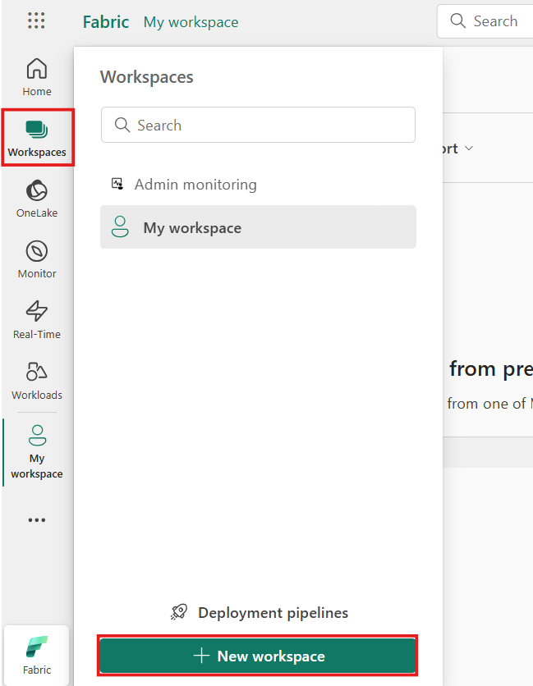

1. The **Create a workspace** pane opens.
   * Give the workspace a unique name (mandatory).
   * Provide a description of the workspace (optional).
   * Assign the workspace to a domain (optional).

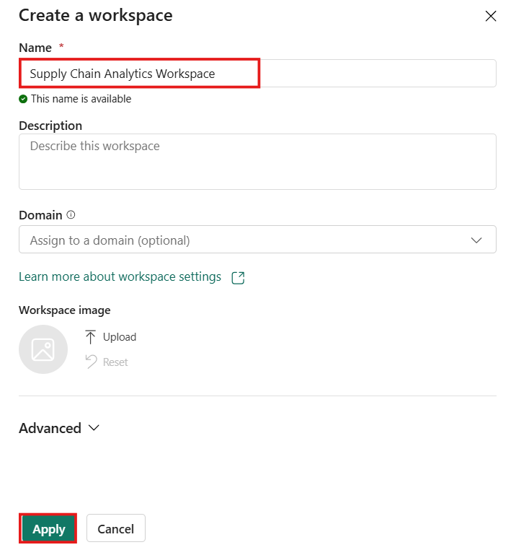If you are a domain contributor for the workspace, you can associate the workspace to a domain, or you can change an existing association.

1. When done, either continue to the advanced settings, or select **Apply**.

## Exercise 2 – Create a SQL Database in Microsoft Fabric

1. Ensure you are in the Workspace you created earlier by selecting the **Workspaces** icon in the navigation bar, and then selecting the Workspace you created in the last step.
2. 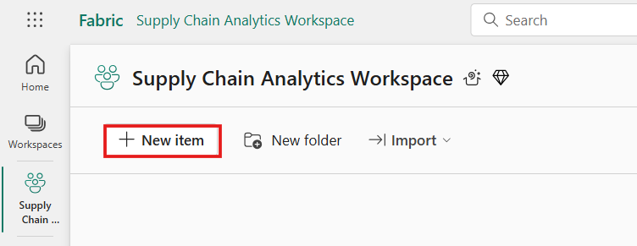Create a Fabric SQL database by selecting the **+ New item**.
3. 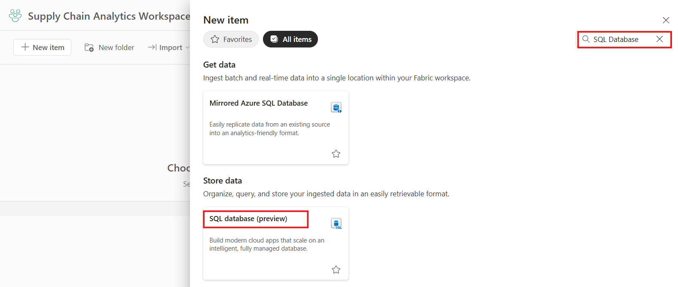In the **New Item | All Items** panel, scroll to the **Store Data** area and select **SQL database (preview)**.
4. 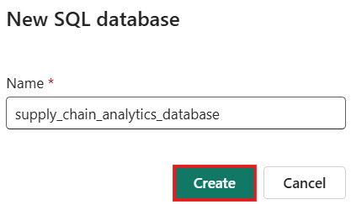Fill in the **Name** field with the text ***supply_chain_analytics_database*** and select the **Create** button. Database creation should take less than a minute.

## Exercise 3 – Ingest sample data and create objects and data

### **Task-1: Open the Query Editor in the Fabric Portal**

1. Open the SQL database in Fabric database you created in the last tutorial step. You can find it in the navigation bar of the Fabric portal, or by finding it in your Workspace for this tutorial.

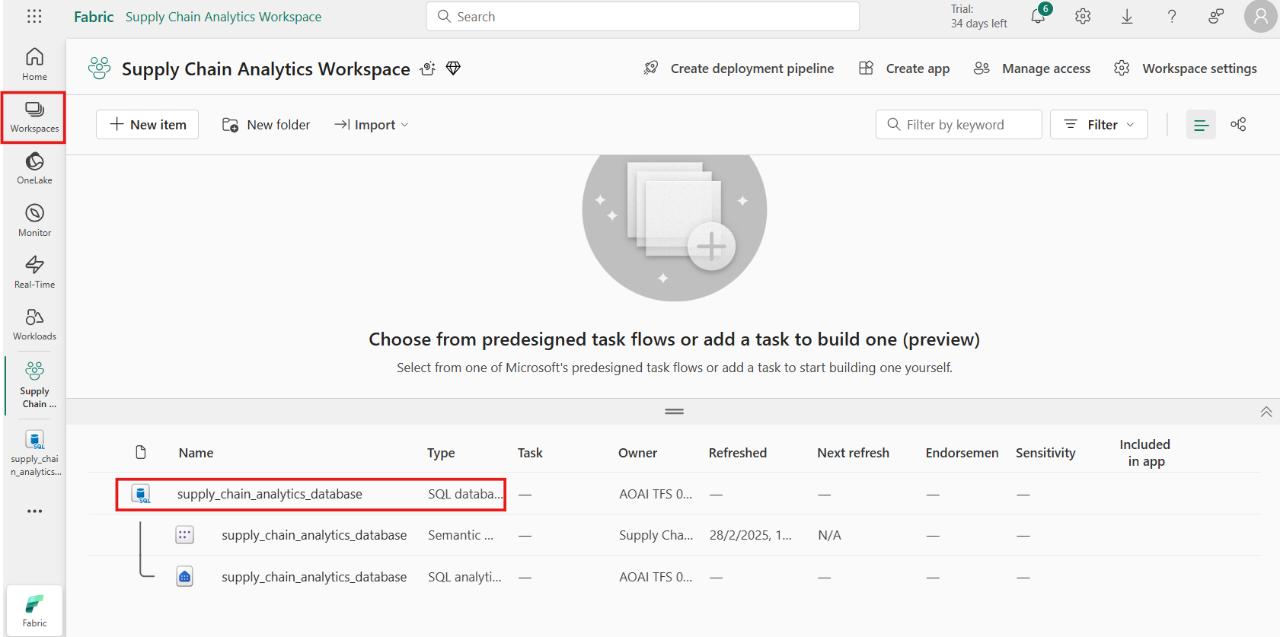

1. 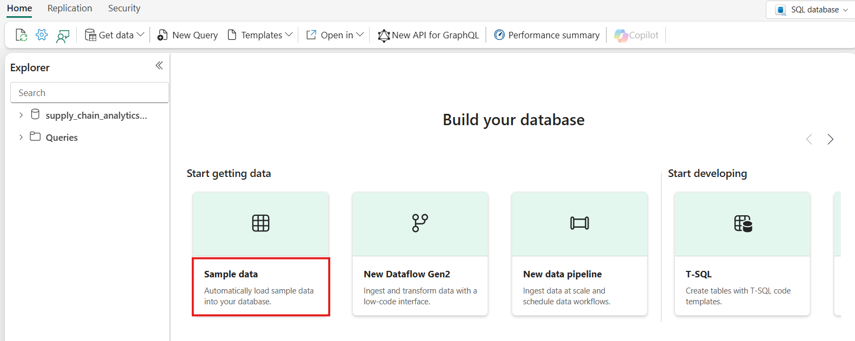Select the **Sample data**button. This takes a few moments to populate your tutorial database with the SalesLT sample data.
2. Check the Notifications area to ensure the import is complete before you proceed.

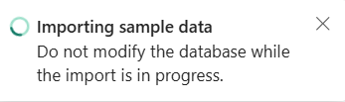

1. Notifications show you when the import of the sample data is complete. Your SQL database in Fabric now contains the SalesLT schema and associated tables.

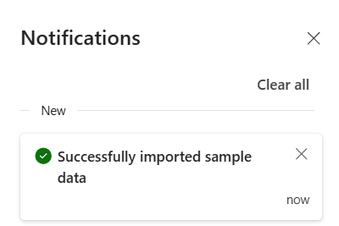

### **Task-2: Use the SQL database in the SQL Editor**

1. In your database view, start by selecting **New Query** from the icon bar. This brings up a query editor.

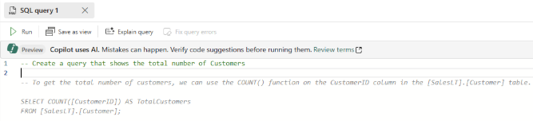Type a T-SQL comment at the top of the query, such as -- Create a query that shows the total number of customers and press **Enter**. You get a result similar to this one:

1. 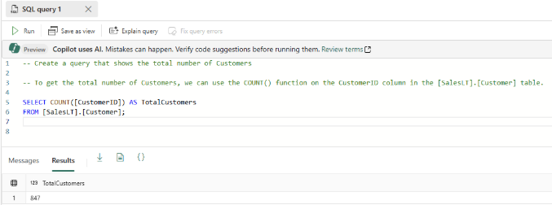Pressing the "Tab" key implements the suggested code:
2. 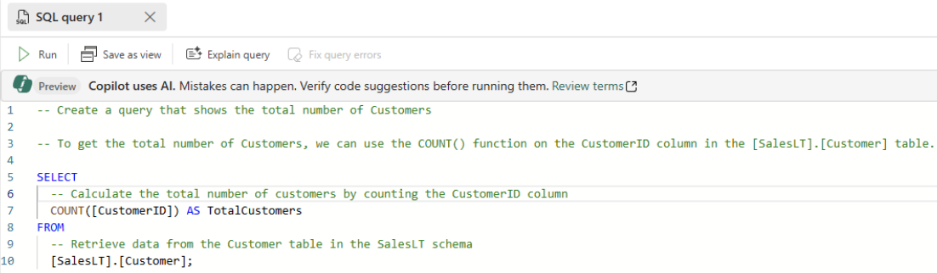Select **Explain query** in the icon bar of the Query editor to insert comments in your code to explain each major step:

In a production environment, you might have data that is already in a normalized format for day-to-day application operations, which you have simulated here with the SalesLT data. As you create a query, it's saved automatically in the **Queries** item in the **Explorer** pane. You should see your query as "SQL query 1". By default, the system numbers the queries like "SQL query 1", but you can select the ellipses next to the query name to duplicate, rename or delete the query.

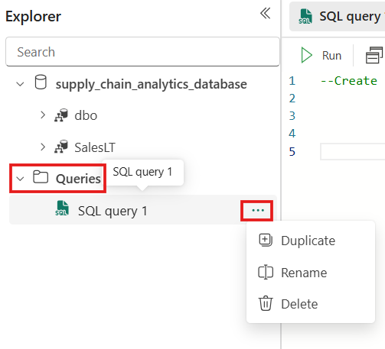

### **Task-3: Insert data using Transact-SQL**

The following steps use a T-SQL script to create a schema, table, and data for the simulated data for supply chain analysis.

1. 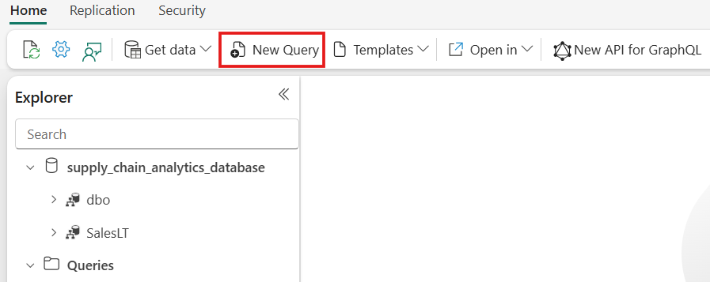Select the **New Query** button in the toolbar of the SQL database to create a new query.
2. Paste the following script in the Query area and select **Run** to execute it. The following T-SQL script:
   1. Creates a schema named SupplyChain.
   2. Creates a table named SupplyChain.Warehouse.
   3. Populates the SupplyChain.Warehouse table with some randomly created product data from SalesLT.Product.

**SQL**

/* Create the Tutorial Schema called SupplyChain for all tutorial objects */

CREATE SCHEMA SupplyChain;

GO

/* Create a Warehouse table in the Tutorial Schema

NOTE: This table is just a set of INT's as Keys,

tertiary tables will be added later

*/

CREATE TABLE SupplyChain.Warehouse (

ProductID INT PRIMARY KEY -- ProductID to link to Products and Sales tables

, ComponentID INT -- Component Identifier, for this tutorial we assume one per product, would normalize into more tables

, SupplierID INT -- Supplier Identifier, would normalize into more tables

, SupplierLocationID INT -- Supplier Location Identifier, would normalize into more tables

, QuantityOnHand INT); -- Current amount of components in warehouse

GO

/* Insert data from the Products table into the Warehouse table. Generate other data for this tutorial */

INSERT INTO SupplyChain.Warehouse (ProductID, ComponentID, SupplierID, SupplierLocationID, QuantityOnHand)

SELECT p.ProductID,

ABS(CHECKSUM(NEWID())) % 10 + 1 AS ComponentID,

ABS(CHECKSUM(NEWID())) % 10 + 1 AS SupplierID,

ABS(CHECKSUM(NEWID())) % 10 + 1 AS SupplierLocationID,

ABS(CHECKSUM(NEWID())) % 100 + 1 AS QuantityOnHand

FROM [SalesLT].[Product] AS p;

GO

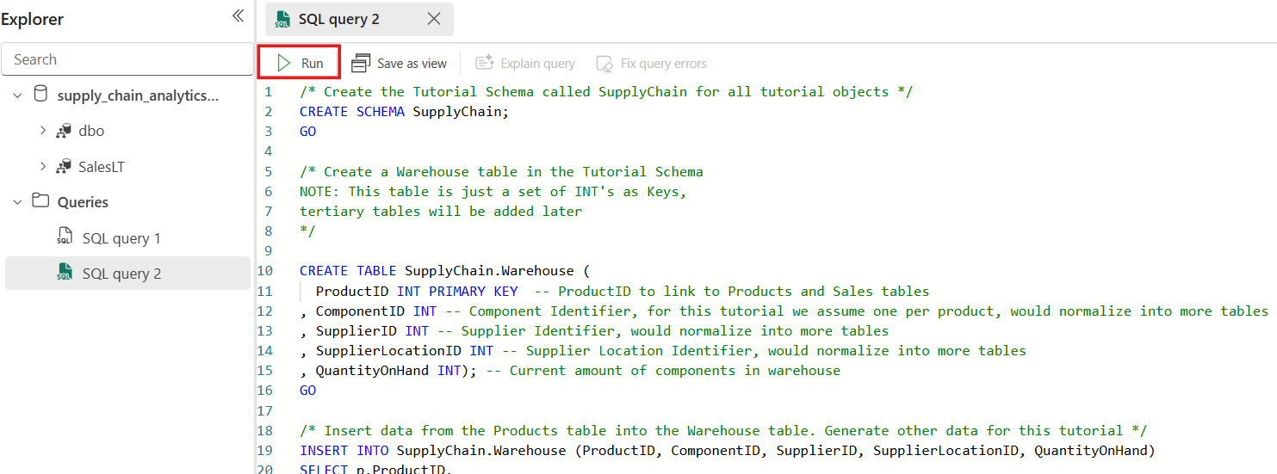

Your SQL database in Fabric database now includes Warehouse information. You'll use this data in a later step in this tutorial.

1. 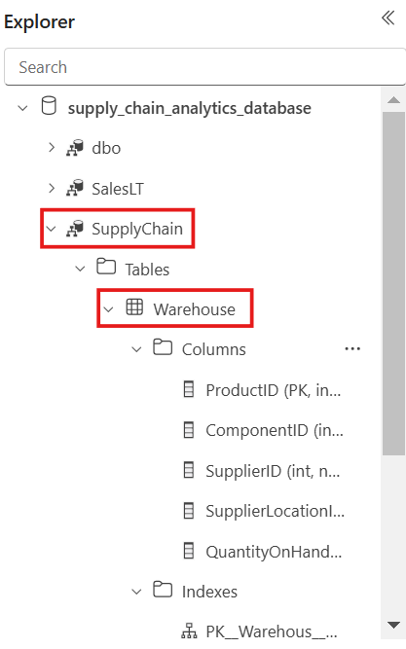You can select these tables in the **Explorer** pane, and the table data is displayed – no need to write a query to see it.

### **Task-4: Insert data using a Microsoft Fabric Pipeline**

Another way you can import data into and export data out of your SQL database in Fabric is to use a Microsoft Fabric Data Pipeline. Data pipelines offer an alternative to using commands, instead using a graphical user interface. A data pipeline is a logical grouping of activities that together perform a data ingestion task. Pipelines allow you to manage extract, transform, and load (ETL) activities instead of managing each one individually.

Microsoft Fabric Pipelines can contain a Dataflow. **Dataflow Gen2** uses a Power Query interface that allows you to perform transformations and other operations on the data. You'll use this interface to bring in data from the Northwind Traders company, which Contoso partners with. They're currently using the same suppliers, so you'll import their data and show the names of these suppliers using a view that you'll create in another step in this tutorial.

To get started, open the SQL database view of the sample database in the Fabric portal,

1. 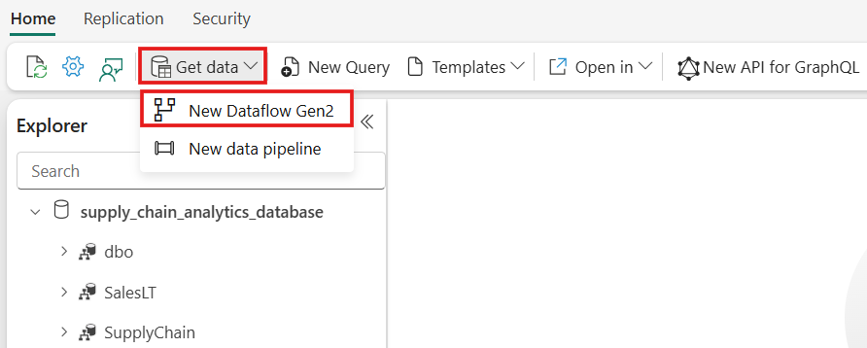Select the **Get Data** button from the menu bar and Select **New Dataflow Gen2**.
2. In the Power Query view, select the **Get Data** button. This starts a guided process rather than jumping to a particular data area.

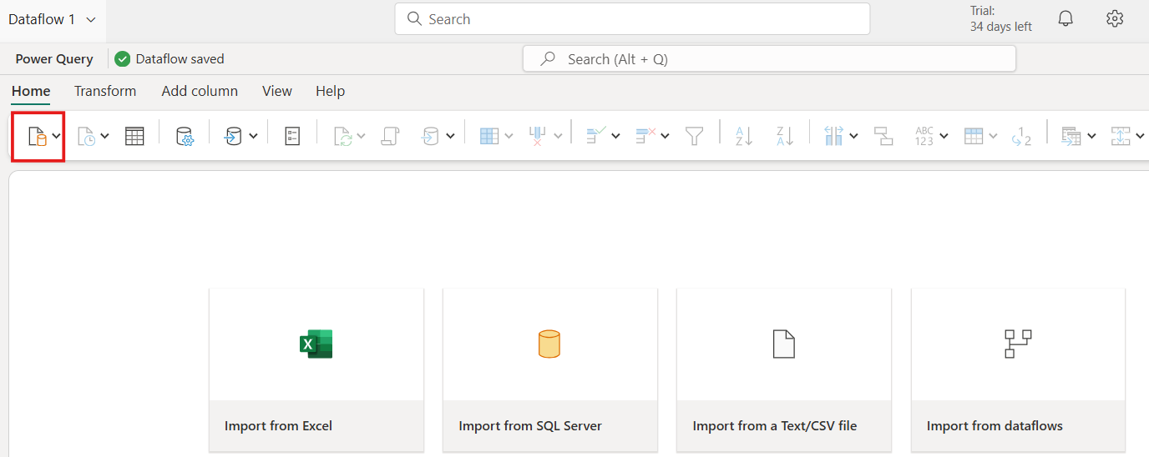

1. 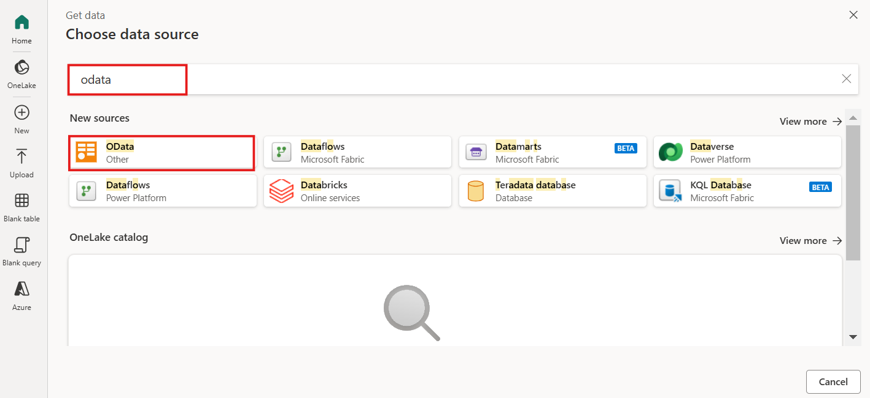In the search box of the **Choose Data Source**, view type **odata** and Select **OData** from the **New sources** results.
2. In the URL text box of the **Connect to data source** view, type the text: *https://services.odata.org/v4/northwind/northwind.svc/* for the Open Data feed of the Northwind sample database. Select the **Next** button to continue.

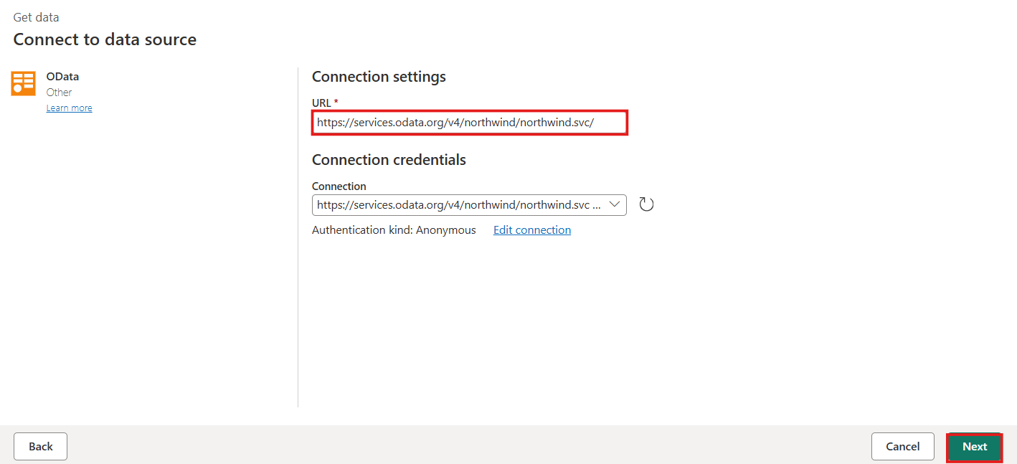

1. 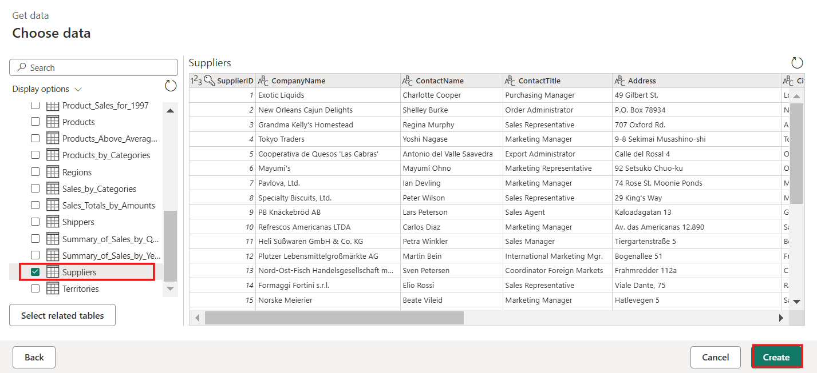Scroll down to the **Suppliers** table from the OData feed and select the checkbox next to it. Then select the **Create** button.
2. Select the **+** plus-symbol next to the **Data Destination** section of the **Query Settings**, and select **SQL database** from the list.

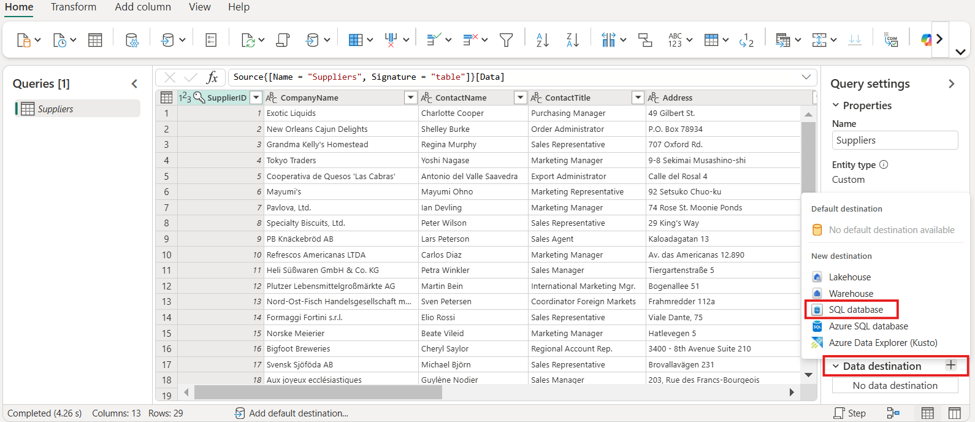

1. On the **Connect to data destination** page, ensure the **Authentication kind** is set to **Organizational account**. Select **Sign in** and enter your Microsoft Entra ID credentials to the database.

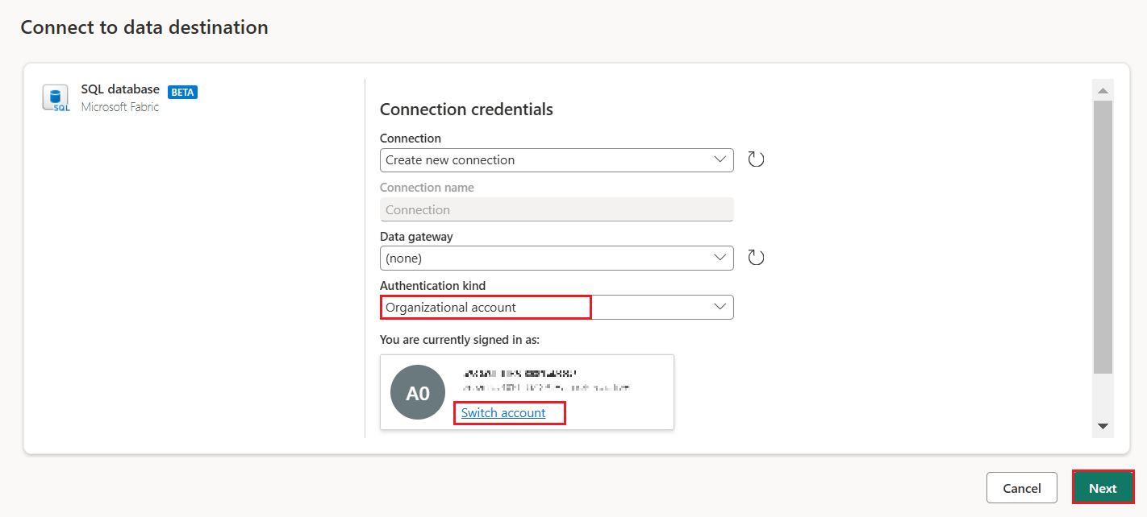Once you're successfully connected, select the **Next** button.

1. Select the Workspace name you created in the first step of this tutorial in the **Choose destination target** section.

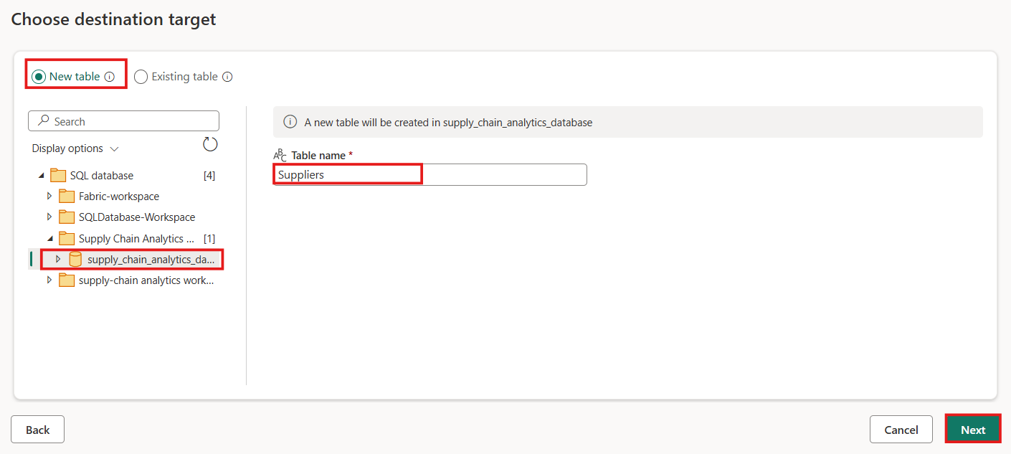Select your database that shows underneath it. Ensure that the **New table** radio button is selected and leave the name of the table as **Suppliers** and select the **Next** button.

1. 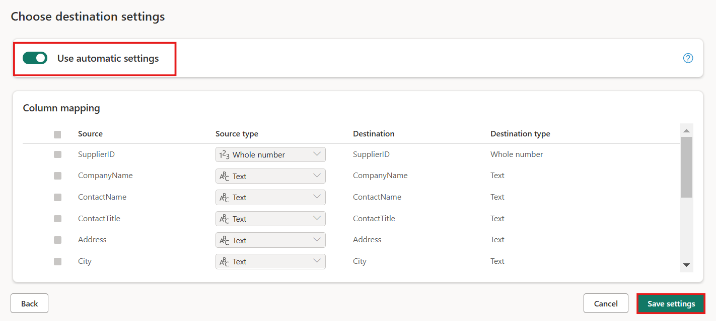Leave the **Use automatic settings** slider set on the **Choose destination settings** view and select the **Save settings** button.
2. Select the **Publish** button to start the data transfer.

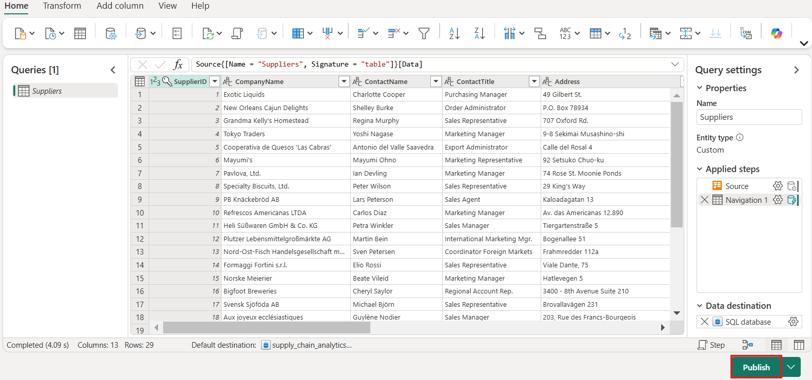

1. 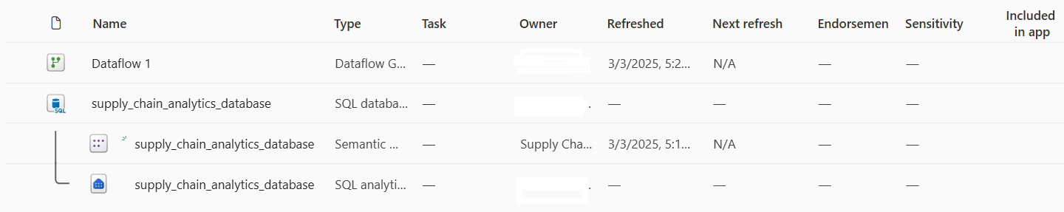You're returned to your Workspace view, where you can find the new Dataflow item.
2. 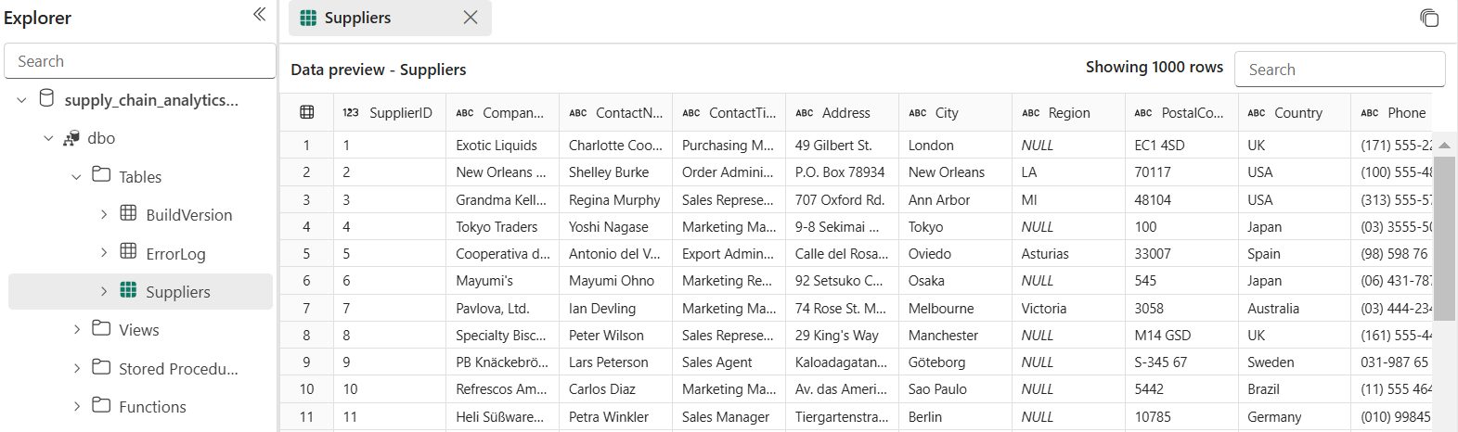When the **Refreshed** column shows the current date and time, you can select your database name in the **Explorer** then expand the dbo schema to show the new table. (You might have to select the **Refresh** icon in the toolbar.)

The data is now ingested into your database. You can now create a query that combines the data from the Suppliers table using this tertiary table.

## Exercise 4 – Query the database and review copilot features

### **Task-1: Transact-SQL Queries**

You can type Transact-SQL (T-SQL) statements in a query window.

1. 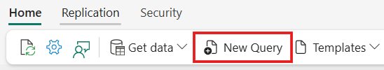In ribbon of the database in the Fabric portal, select the **New Query** button.
2. Copy the following T-SQL script and paste it in the query window. This sample script performs a simple **TOP 10** query, and creates a view based on a simple analytical T-SQL query. The new view **SupplyChain.vProductsbySuppliers** will be used later in this tutorial.

Select the **Run** button in the toolbar to execute the T-SQL query.

**SQL**

-- Show the top 10 selling items

SELECT TOP 10

[P].[ProductID],

[P].[Name],

SUM([SOD].[OrderQty]) AS TotalQuantitySold

FROM [SalesLT].[Product] AS P

INNER JOIN [SalesLT].[SalesOrderDetail] AS SOD ON [P].[ProductID] = [SOD].[ProductID]

GROUP BY [P].[ProductID], [P].[Name]

ORDER BY TotalQuantitySold DESC;

GO

/* Create View that will be used in the SQL GraphQL Endpoint */

CREATE VIEW SupplyChain.vProductsbySuppliers AS

SELECT COUNT(a.ProductID) AS ProductCount

, a.SupplierLocationID

, b.CompanyName

FROM SupplyChain.Warehouse AS a

INNER JOIN dbo.Suppliers AS b ON a.SupplierID = b.SupplierID

GROUP BY a.SupplierLocationID, b.CompanyName;

GO

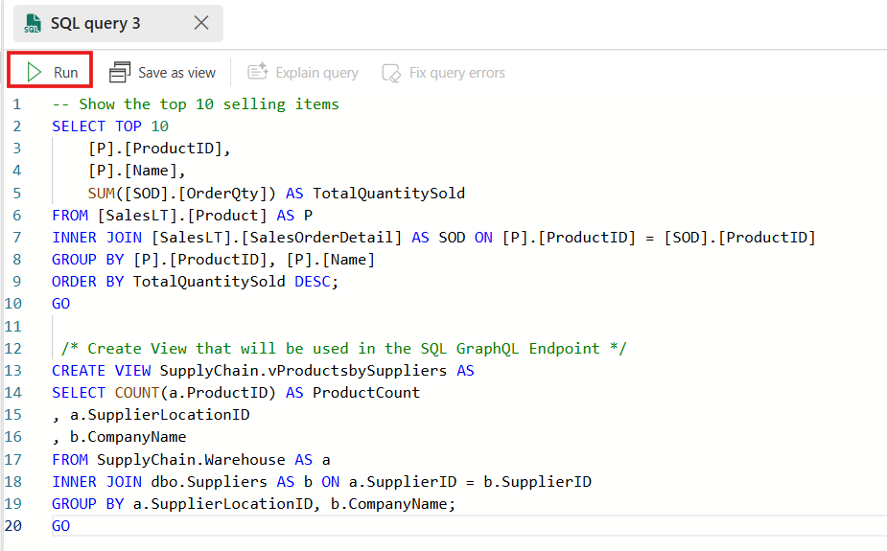

1. You can select the ellipses (...) next to the name under the Object View to duplicate, rename, or delete it.
2. 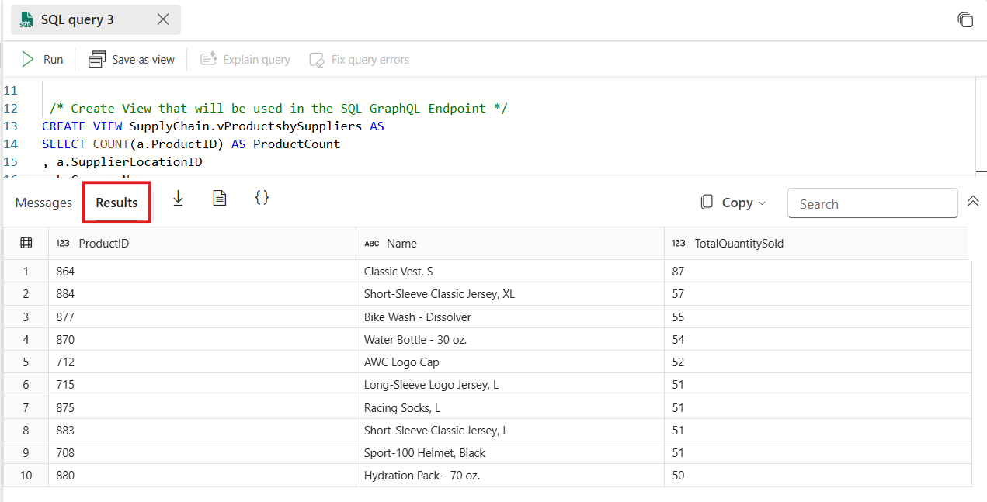The desired results will be displayed based on the query.

### **Task-2: Copilot for SQL database**

The query editor panel includes Copilot for SQL database. Copilot for SQL database does not use the data in tables to generate T-SQL suggestions, on the names of database objects such as table and view names, column names, primary key, and foreign key metadata to generate T-SQL code.

You also have access to various **Quick actions**. In the ribbon of the SQL query editor, the **Fix** and **Explain** options are quick actions. Highlight a SQL query of your choice, then select one of the quick action buttons to perform the selected action on your query.

1. Highlight the code you just pasted in your query window.
2. Press the **Explain query** button in the query window ribbon.
3. Copilot adds in comments that help explain what each step of the code is doing.

### **Task-3: Performance Monitoring in SQL database in Fabric**

As your queries run in your SQL database in Fabric, the system collects performance metrics to display in the **Performance Dashboard**. You can use the Performance Dashboard to view database performance metrics, to identify performance bottlenecks, and find solutions to performance issues.

In the Fabric portal, there are two ways to launch the Performance Dashboard on your SQL database:

* On the **Home** toolbar in the Query with the SQL query editor, select **Performance summary**.
* Select **performance summary**. The entire performance summary is displayed such as CPU consumption, Allocated size, User connections etc.

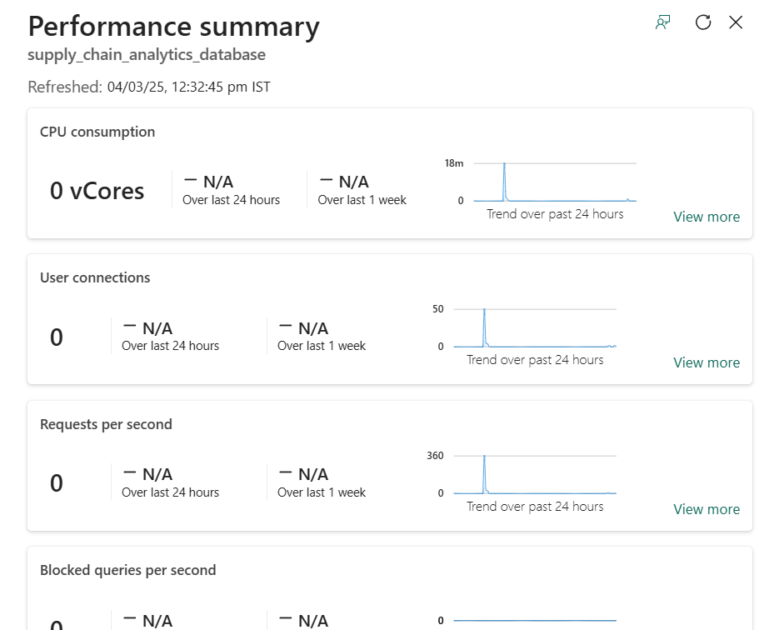

### **Task-4: Backups in SQL database in Fabric**

SQL database in Fabric automatically takes backups for you, and you can see these backups in the properties that you access through the database view of the Fabric portal.

1. Open your database view in the Fabric portal and select the Settings icon in the toolbar.

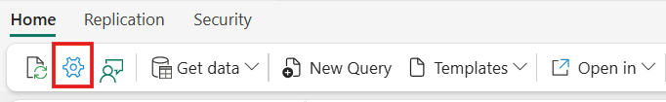

1. Select the **Restore points** page. This view shows the recent point in time backups that have been taken on your database.

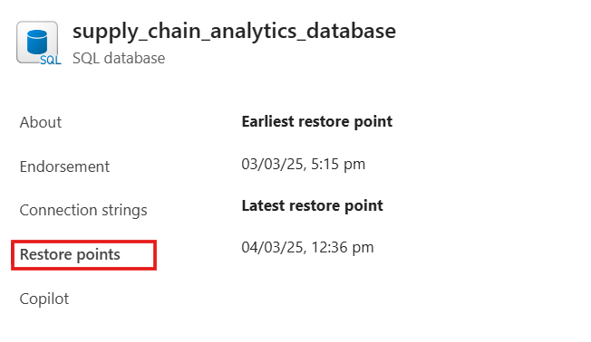

### **Task-5: Security in SQL database in Fabric**

You'll now grant access to another account in your organization and then control their database securables using Schemas.

1. 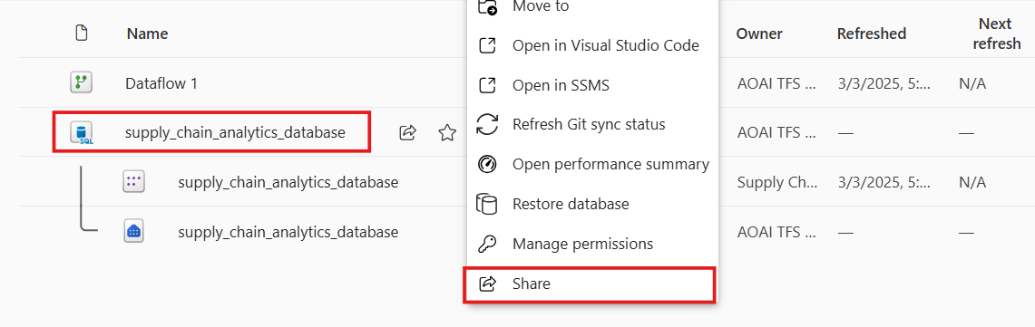From your Fabric Workspace, select the context menu (...) of the SQL database, then select **Share** from the menu.
2. Enter a contact name from your organization to receive the sharing invitation notification and Select **Grant**.

You don't need to grant any further permissions in this area – sharing the database to the account gives the sharing contact access to connect.

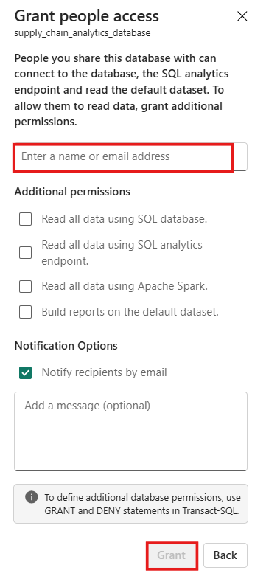

1. 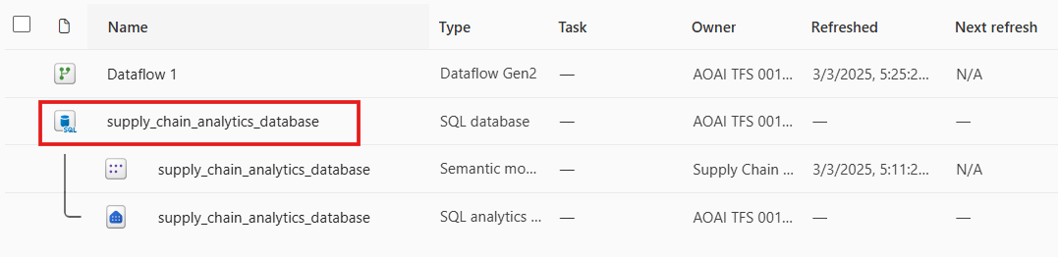Open the SQL database by selecting on it in the workspace view.
2. Select **Security** in the menu bar of the database view. Select **Manage SQL security** in the ribbon.

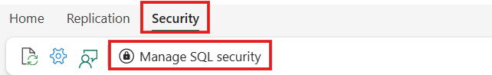

1. 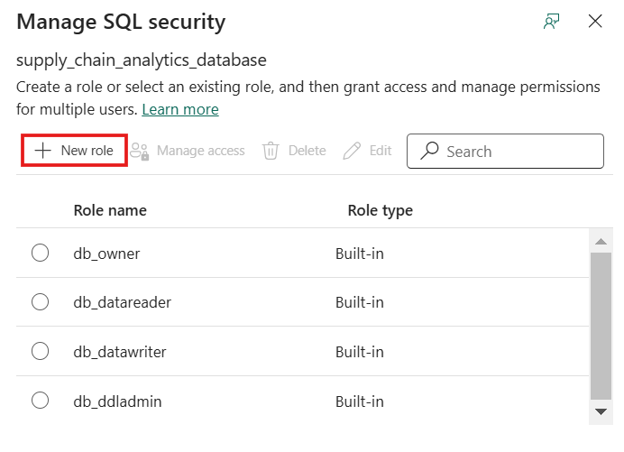In this panel, you can select a current database role to add accounts to it. Select the **+ New role** item.
2. 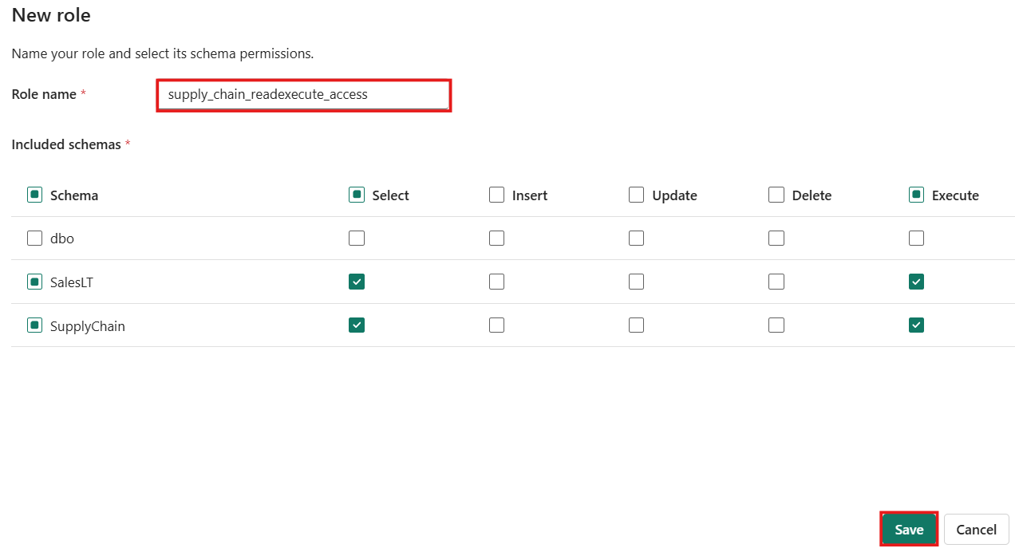Name the role **supply_chain_readexecute_access** and then select the SalesLT and SupplyChain schemas. De-select all checkboxes except **Select** and **Execute**. Select **Save**.
3. In the **Manage SQL security** panel, select the radio-box next to the new role, and select **Manage access** in the menu.

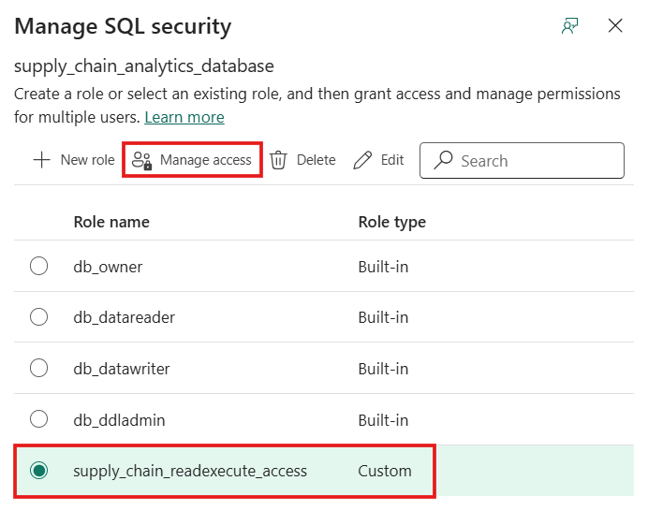

1. 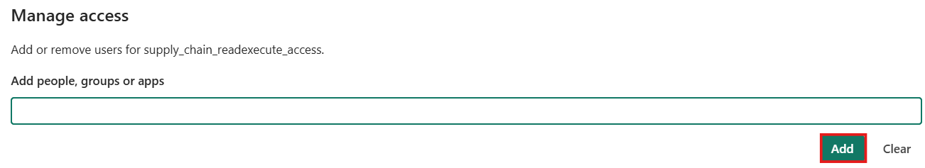Enter the name of the account in your organization you shared the database to and select the **Add** button, and then select **Save**.

You can allow the account to view data and run stored procedures in the database with the combination of: the Share action, and granting the role both SELECT and EXECUTE permissions on the two schemas.

## Exercise 5 – Use the SQL analytics endpoint to query data

### **Task-1: Query the data with the SQL analytics endpoint**

You can query any of the mirrored data in the SQL analytics endpoint using standard Transact-SQL statements that are compatible with a Fabric warehouse.

1. 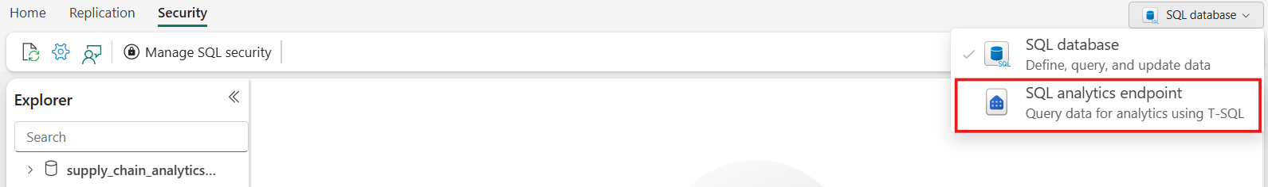You can access the SQL analytics endpoint in the **database view**.
2. In this step, create a view over the mirrored data, and then create a report to show the results.

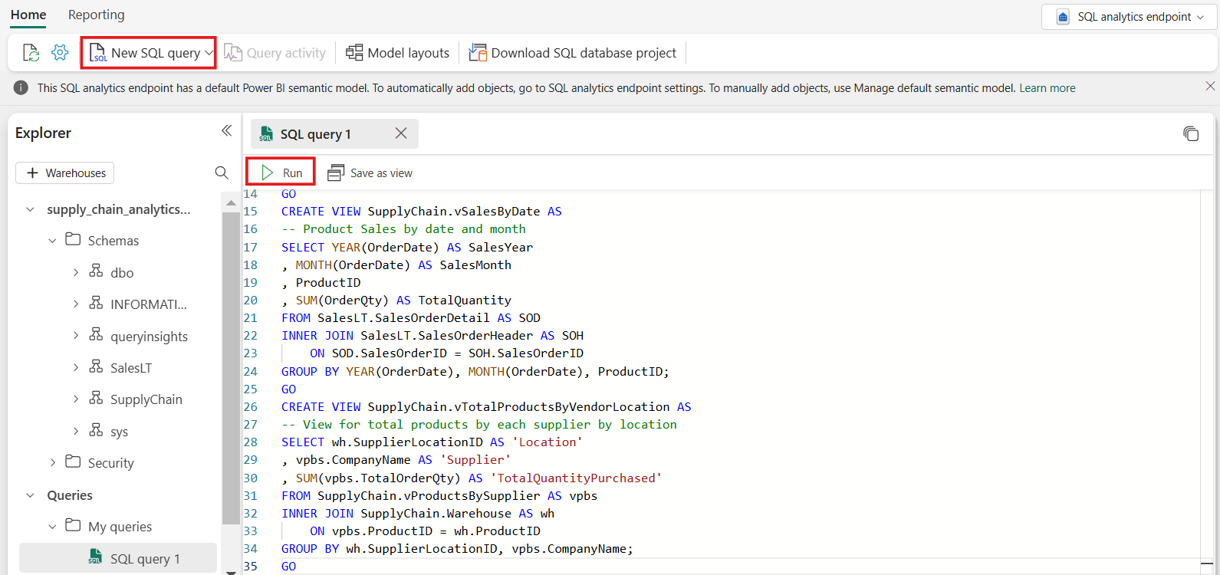Ensure you're in the SQL analytics endpoint, and then open a new Query window using the icon bar that depicts a paper with the letters **SQL** and paste the following Transact-SQL Code and select **Run** to execute it.

**SQL**

CREATE VIEW SupplyChain.vProductsBySupplier AS

-- View for total products by each supplier

SELECT sod.ProductID

, sup.CompanyName

, SUM(sod.OrderQty) AS TotalOrderQty

FROM SalesLT.SalesOrderHeader AS soh

INNER JOIN SalesLT.SalesOrderDetail AS sod

ON soh.SalesOrderID = sod.SalesOrderID

INNER JOIN SupplyChain.Warehouse AS sc

ON sod.ProductID = sc.ProductID

INNER JOIN dbo.Suppliers AS sup

ON sc.SupplierID = sup.SupplierID

GROUP BY sup.CompanyName, sod.ProductID;

GO

CREATE VIEW SupplyChain.vSalesByDate AS

-- Product Sales by date and month

SELECT YEAR(OrderDate) AS SalesYear

, MONTH(OrderDate) AS SalesMonth

, ProductID

, SUM(OrderQty) AS TotalQuantity

FROM SalesLT.SalesOrderDetail AS SOD

INNER JOIN SalesLT.SalesOrderHeader AS SOH

ON SOD.SalesOrderID = SOH.SalesOrderID

GROUP BY YEAR(OrderDate), MONTH(OrderDate), ProductID;

GO

CREATE VIEW SupplyChain.vTotalProductsByVendorLocation AS

-- View for total products by each supplier by location

SELECT wh.SupplierLocationID AS 'Location'

, vpbs.CompanyName AS 'Supplier'

, SUM(vpbs.TotalOrderQty) AS 'TotalQuantityPurchased'

FROM SupplyChain.vProductsBySupplier AS vpbs

INNER JOIN SupplyChain.Warehouse AS wh

ON vpbs.ProductID = wh.ProductID

GROUP BY wh.SupplierLocationID, vpbs.CompanyName;

GO

1. 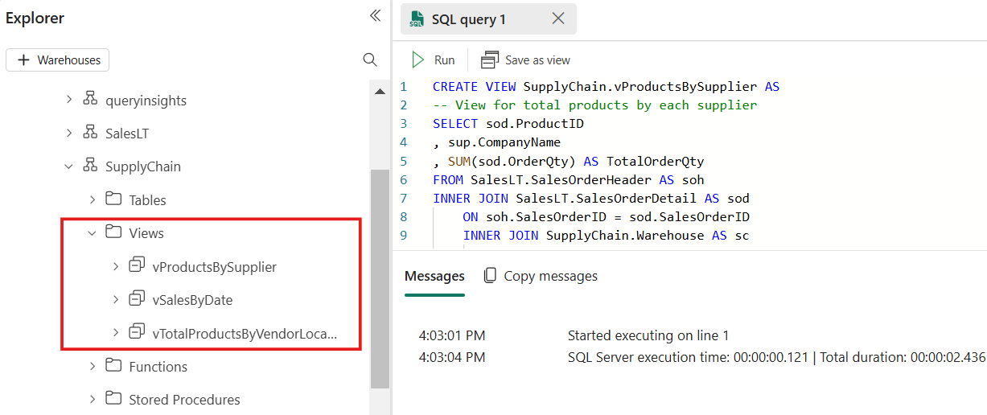This T-SQL query creates three new SQL views, named **SupplyChain.vProductsBySupplier**, **SupplyChain.vSalesByDate**, and **SupplyChain.vTotalProductsByVendorLocation**.

You can now use these views in analytics and reporting. You will create a report using these views in the further steps.

## Exercise 6 – Create and share visualizations

### **Task-1: Find the connection strings to the SQL database**

1. To get your server and database name, open your SQL database in Fabric portal view and select the **Settings** button in the icon bar.

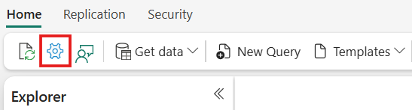

1. 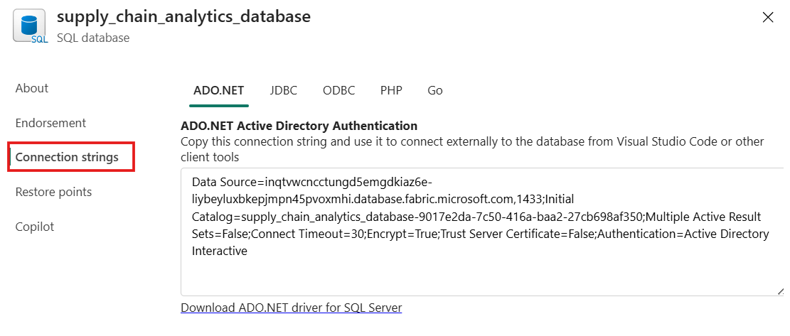Select **Connection Strings** and you'll see a long string that starts with **Data Source...** From there, select the text between the characters **tcp:** through the characters **,1433**. Ensure that you select the entire set of characters there and nothing more for the server name.
2. 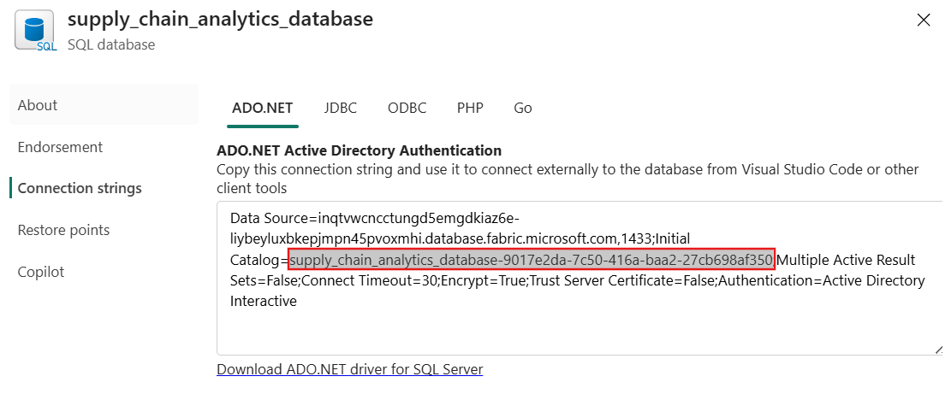For the database name, select all the characters between the characters **Initial Catalog=** and **;MultipleActiveResultSets**.

You can now use these SQL strings in your connection area for tools such as Power BI or SQL Server Management Studio. For Visual Studio Code with the mssql extension, you can paste the entire connection string in the first text box where you make a database connection, so you don't have to select only the server and database names.

### **Task-2: Power BI visualization creation**

As you work with the SQL analytics endpoint, it creates a Data model of the assets. This is an abstracted view of your data and how it's displayed and the relationship between entities. Some of the defaults the system takes might not be as you desire, so you'll now change one portion of the data model for this SQL analytics endpoint to have a specific outcome.

1. 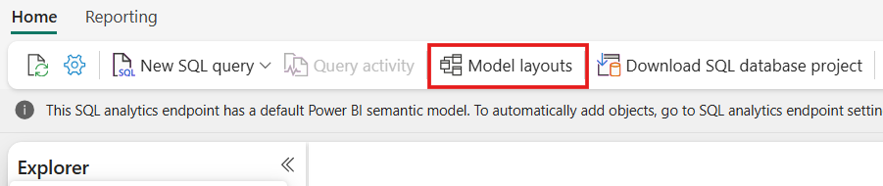In your SQL analytics endpoint view, select the **Model layouts** button in the ribbon.
2. From the resulting view, zoom in and scroll over until you see the **vTotalProductsByVendorLocation** object. Select it.

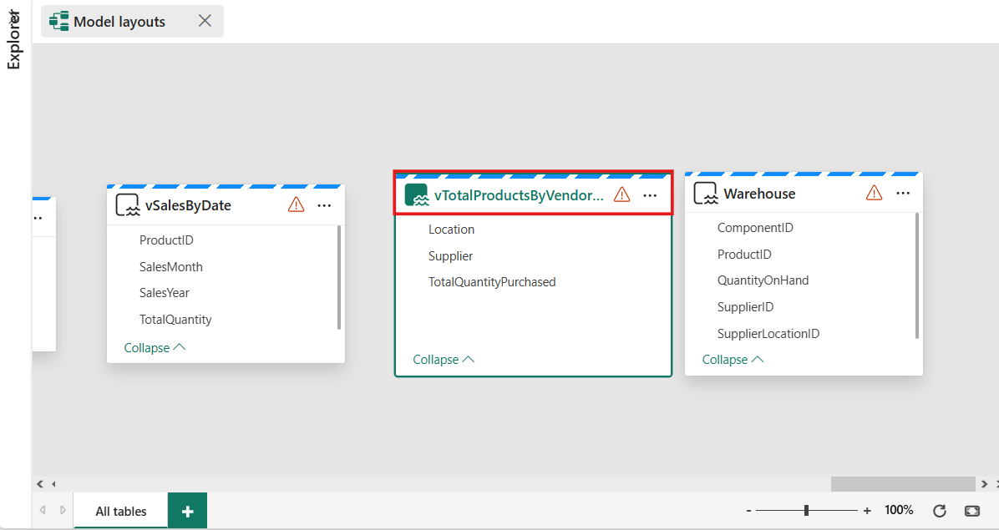

1. 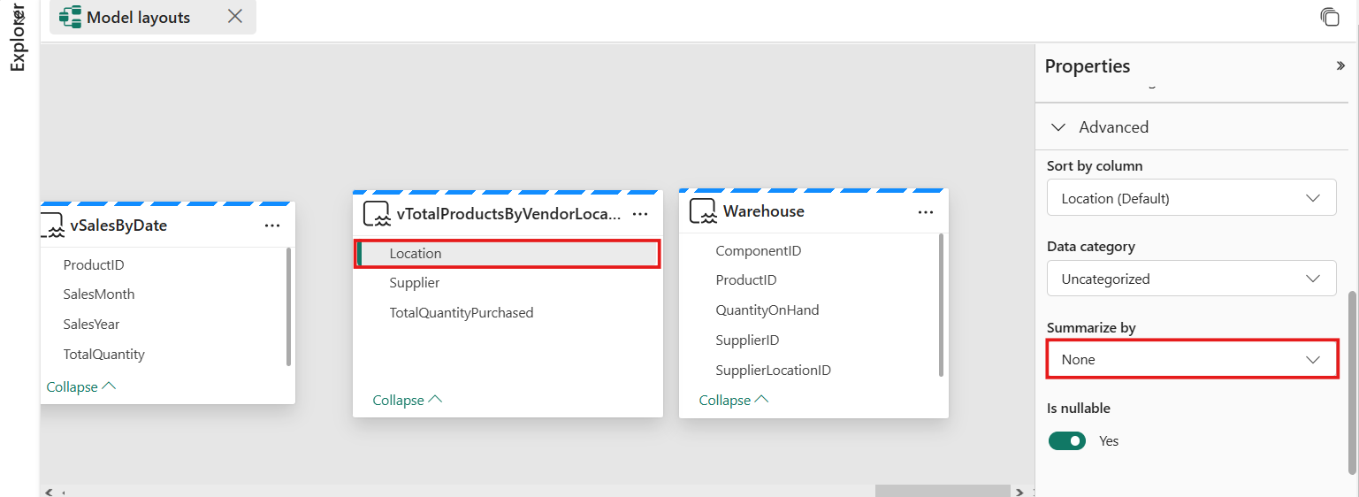In the properties, select the **Location** field, and expand the **Advanced** properties section. You might need to scroll to find it. Set the value of **Summarize by** to **None**. This ensures that when the field is used, it's a discrete number, not a mathematical summarization of that number.

### **Task-3: Create a report**

Here, the task is to create a report based on the views you created in the SQL analytics endpoint in previous steps.

1. 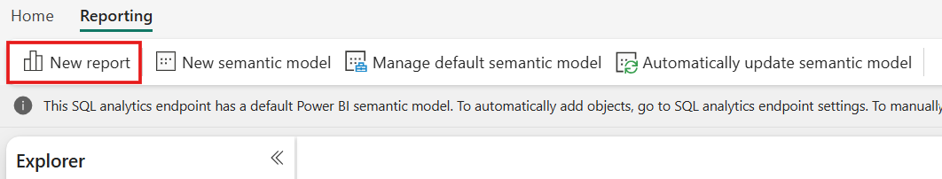Inside the SQL analytics endpoint view, select the **Reporting** button in the menu bar and then the **New report** button in the ribbon.
2. 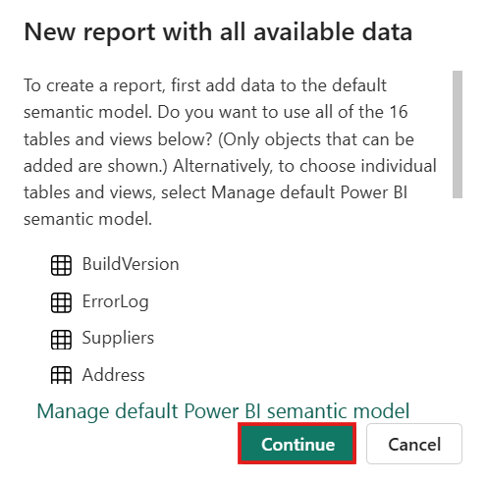From the **New report with all available data** that appears, select the **Continue** button.
3. The Power BI canvas appears, and you're presented with the option to use the Copilot to create your report. Feel free to explore what Copilot can come up with. For the rest of this tutorial, we'll create a new report with objects from earlier steps.

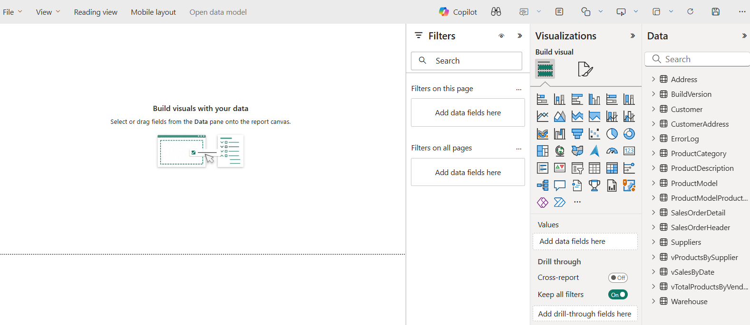

1. 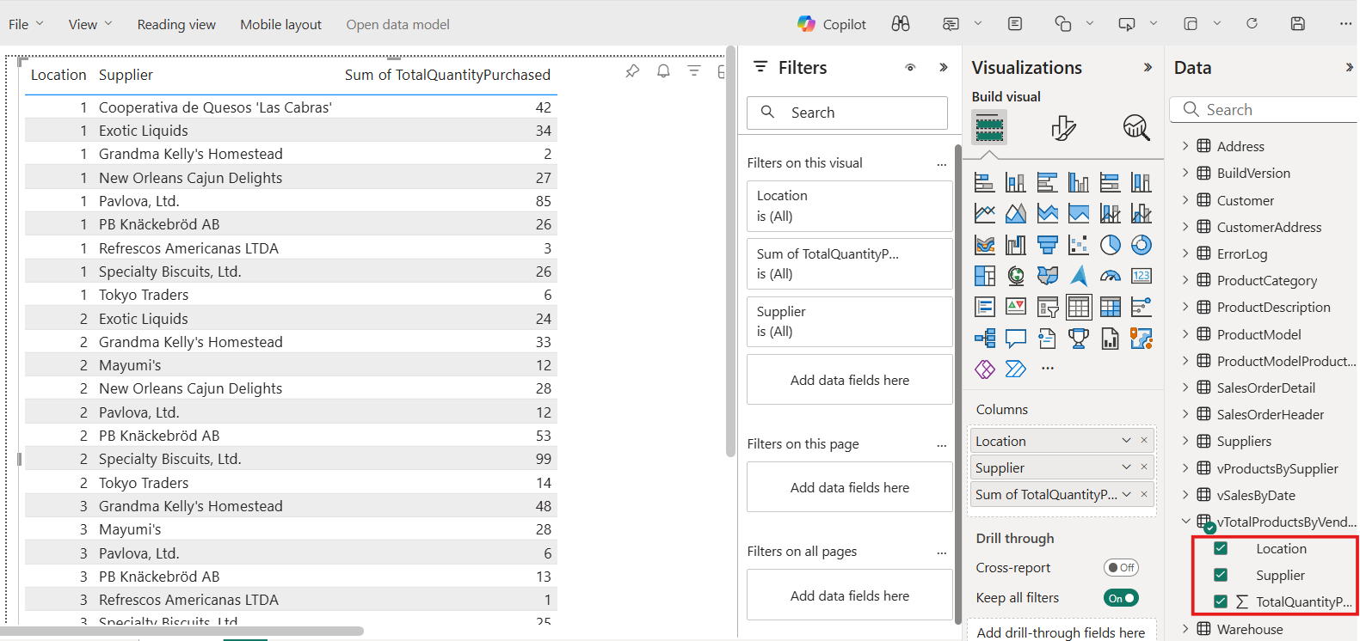Expand the **vTotalProductsByVendor** data object. Select each of the fields you see there. The report takes a moment to gather the results to a text view. You can size this text box if desired.
2. Select in a blank area of the report canvas, and then select **Location** in the **Data** fields area.

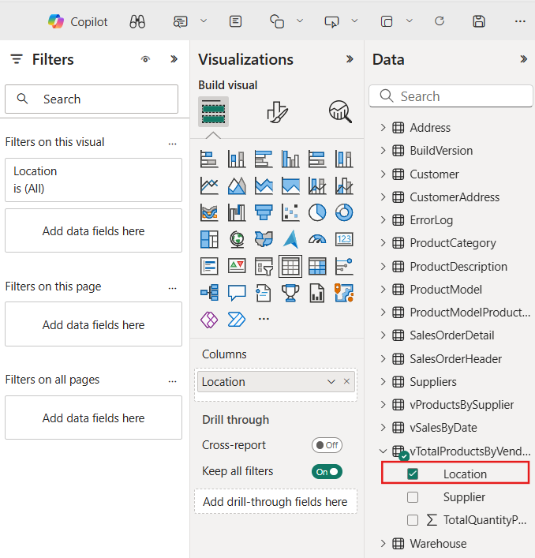

1. 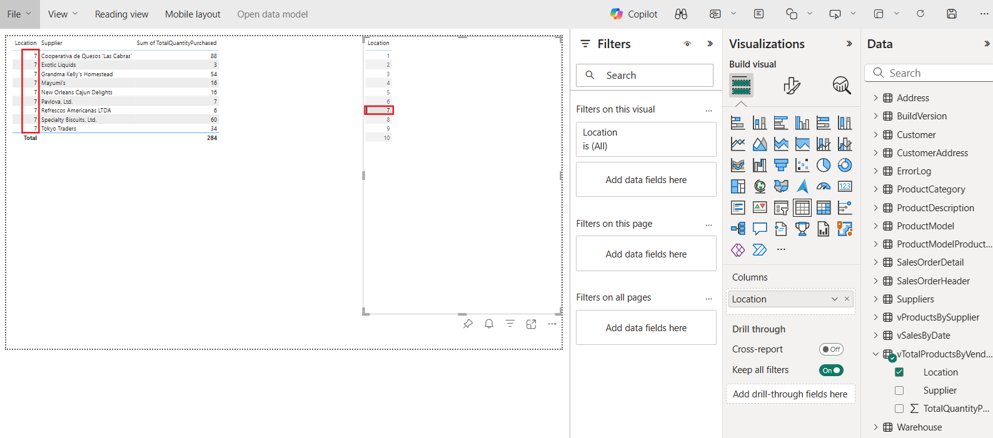Select a value in the box you just created – notice how the first selection of values follows the selection you make in the second box. Select that same value again to clear the selection.
2. 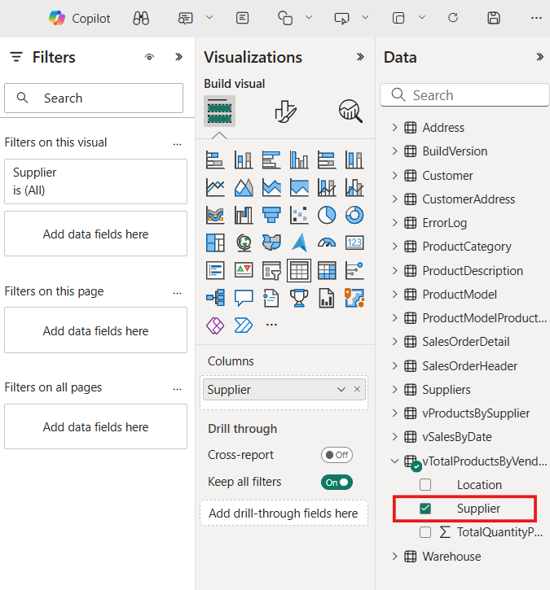Select in a blank area of the reporting canvas, and then select the **Supplier** field.
3. 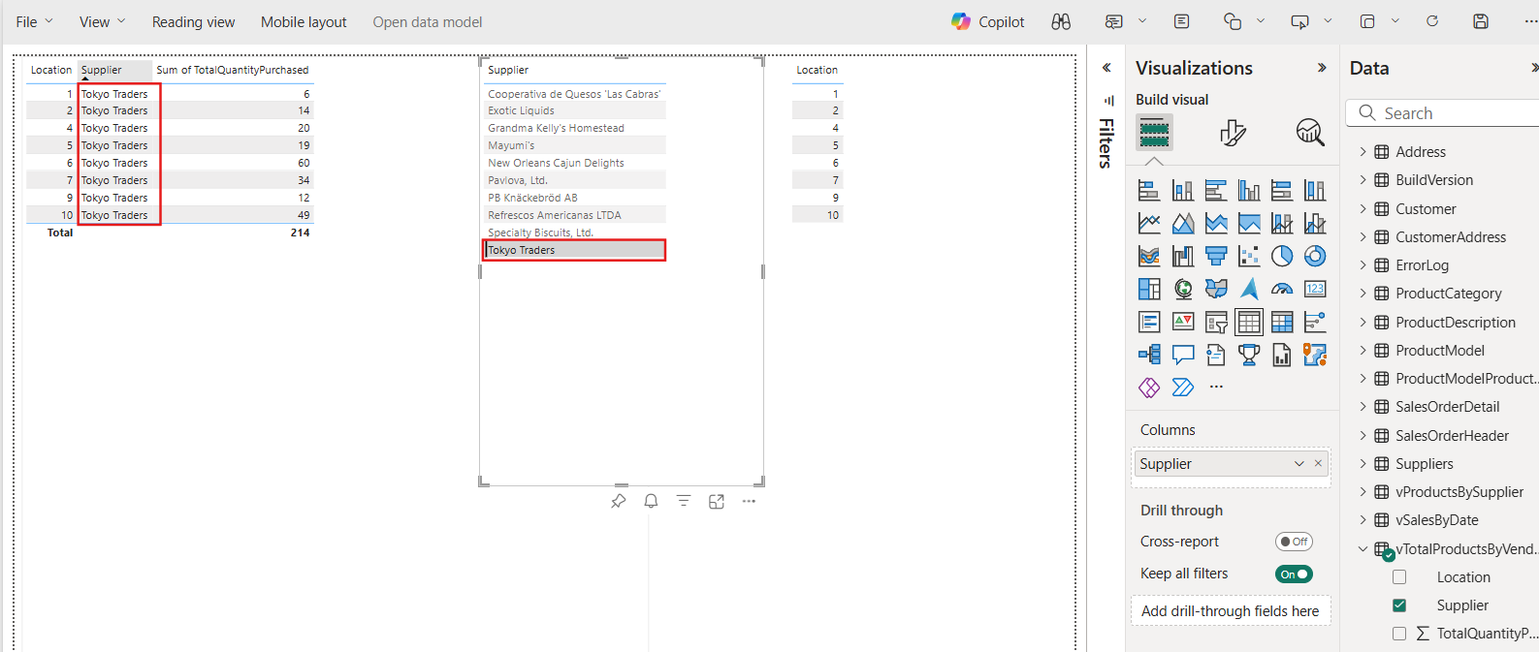Once again, you can select the name of a supplier and the first selection shows the results of just that supplier.

### **Task-4: Save the Power BI item for sharing**

You can save and share your report with other people in your organization.

1. 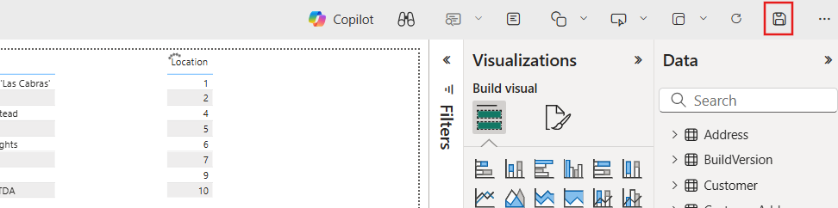Select the **Save** button in the icon box.
2. 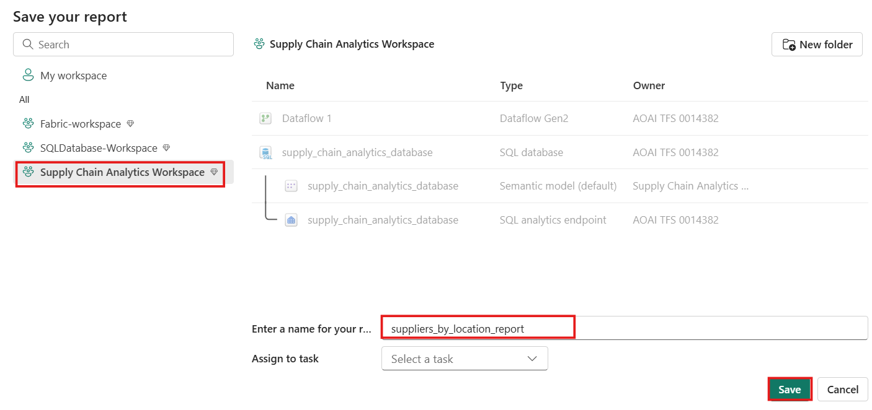Name the report **suppliers_by_location_report**, and ensure you select the correct Workspace for this tutorial.
3. Select the **Share** button in the icon bar to share the report with people in your organization who have access to the proper data elements.

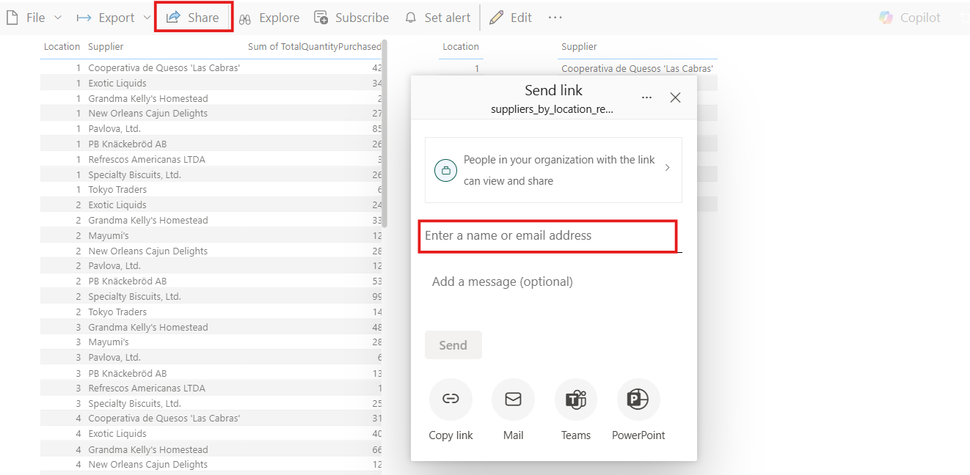

## Exercise 7 – Perform data analysis using Microsoft Fabric Notebooks

### **Task-1: Data analysis with T-SQL notebooks**

1. Navigate to the Workspace you created for this tutorial from the Home of your Microsoft Fabric portal. Select the **New Item** button in the tool bar.

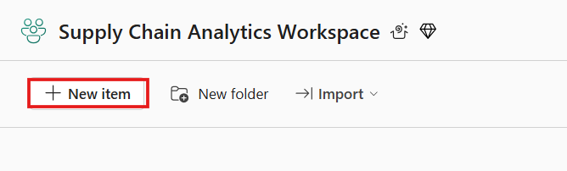

1. Select **All items** and scroll until you see a **Notebook** item. Select that item to create a new Notebook.

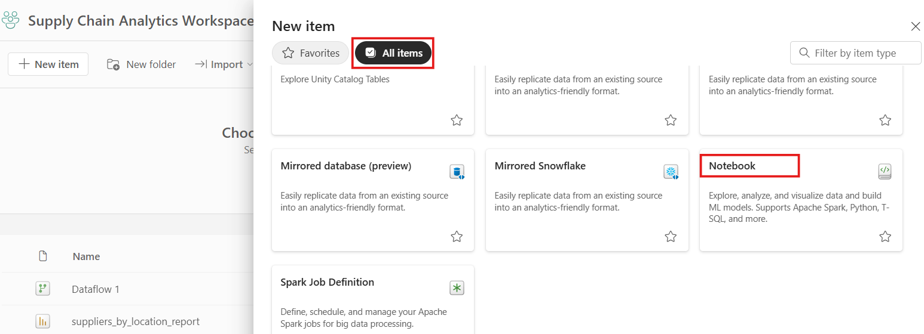

1. 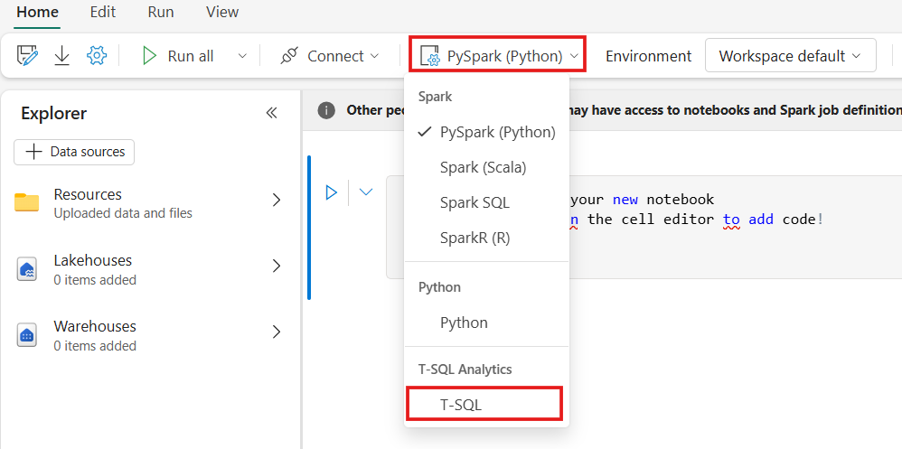In the icon bar, change the environment from **PySpark (Python)** to **T-SQL**.
2. In each code cell, there is a drop-down list for the code language. In the first cell in the Notebook, change the code language from **PySpark (Python)** to **T-SQL**.

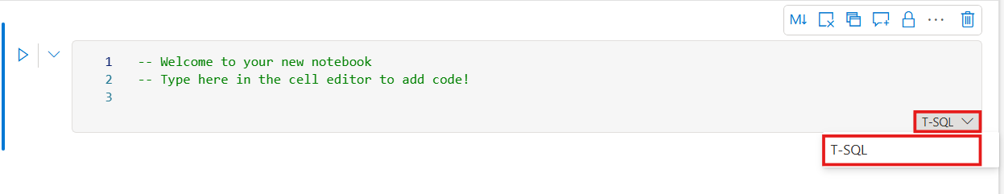

1. 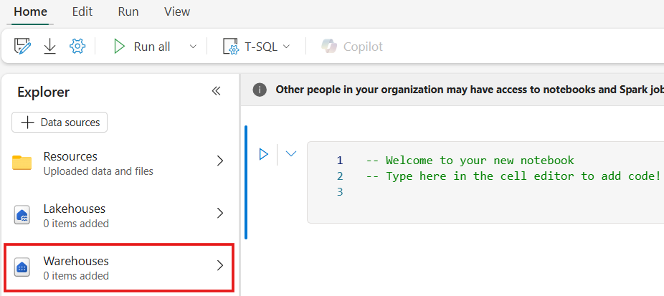In the Notebook **Explorer**, select the **Warehouses** item.
2. 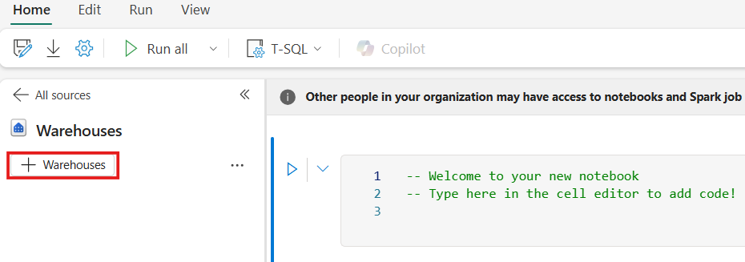Select the **+ Warehouses** button.
3. 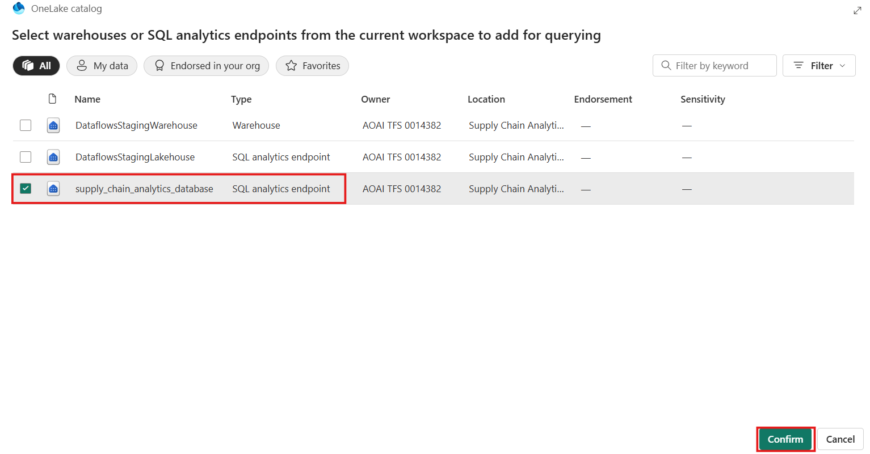Select the **SQL analytics endpoint** object that is named supply_chain_analytics_database, with [the same name of the object you created earlier in this tutorial](https://learn.microsoft.com/en-us/fabric/database/sql/tutorial-create-database). Select **Confirm**.
4. 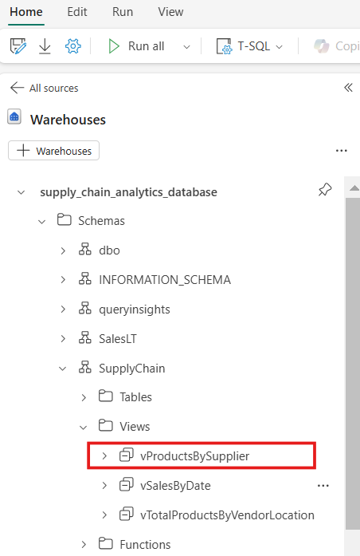Expand the database, expand **Schemas**. Expand the SupplyChain schema. Expand **Views**, and locate the SQL view named **vProductsBySupplier**.
5. Select the ellipses next to that view. and select the option that says SELECT TOP 100.

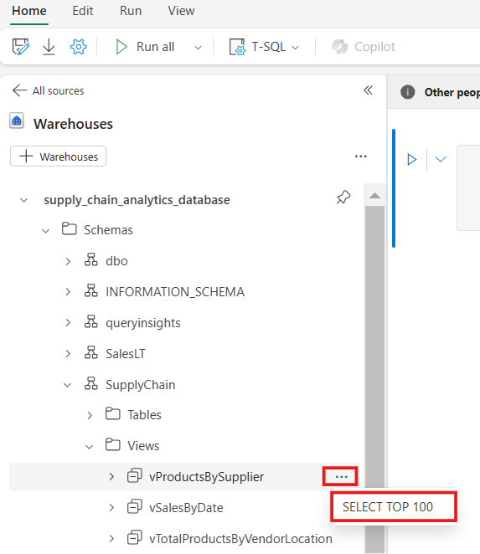

1. 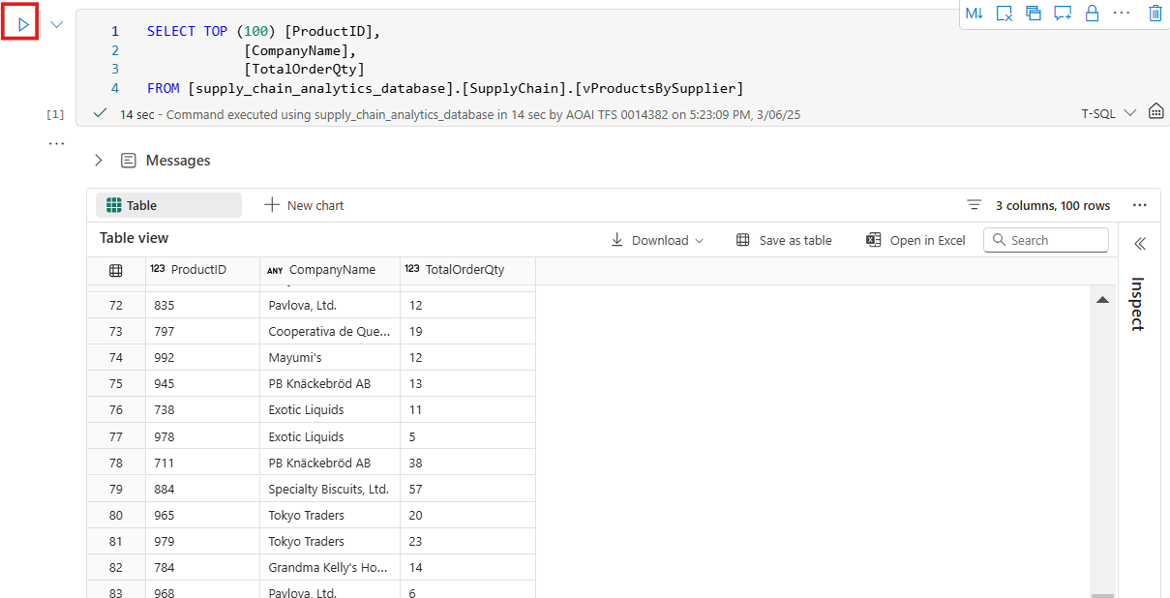This creates a cell with T-SQL code that has the statements pre-populated for you. Select the **Run Cell** button for the cell to run the query and return the results.
2. 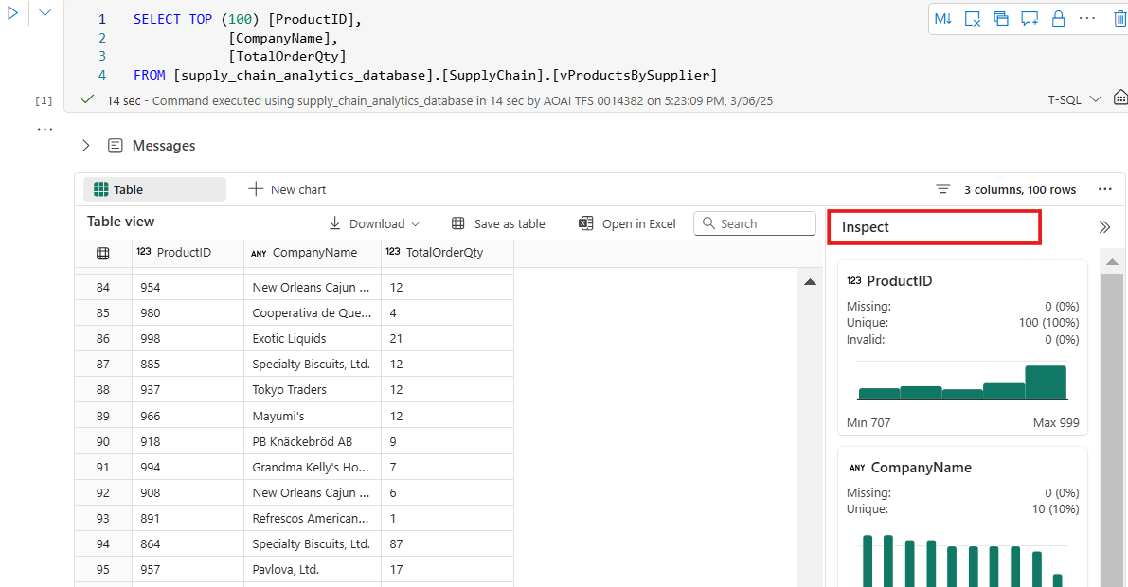In the results, you can see not only the data requested, but buttons that allow you to view charts, save the data as another table, download, and more. To the side of the results you can see a new pane with quick inspection of the data elements, showing minimum and maximum values, missing data, and unique counts of the data returned.
3. 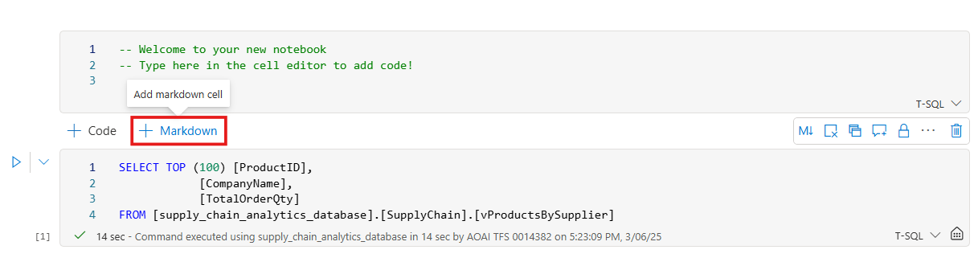Hovering between the code cells shows you a menu to add another cell. Select the **+ Markdown** button.
4. 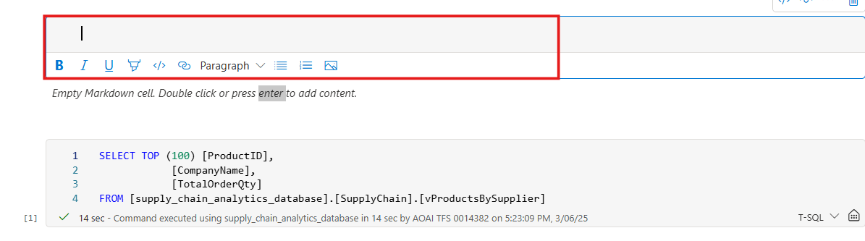This places a text-based field where you can add information. Styling for the text is available in the icon bar, or you can select the </> button to work with Markdown directly. The result of the formatting show as a preview of the formatted text.
5. Select the **Save As** icon in the ribbon.

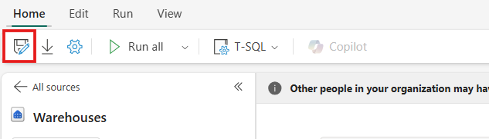

1. Enter the text**products_by_suppliers_notebook**. Ensure you set the location to your Workspace. Select the **Save** button to save the notebook.

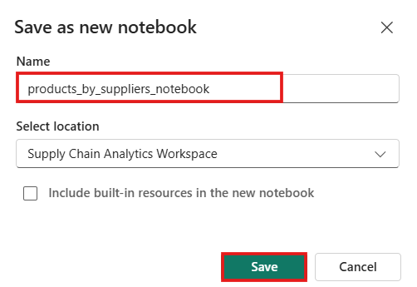

## Exercise 8 – Create an application with DevOps and GraphQL API